Name of Applicant:

This document must be completed and returned in the published format. Failure to comply with this instruction may result in your submission being rejected.

General Information

Procurement Procedure
King’s Pond, Alton
Invitation for Fee Proposals for Stage 1 Design
Introduction
As a summary of the current position of this project we have attached the document “King’s Pond – The Next Steps in Deciding the Way Forward” at Appendix A, together with drawings of the two principal options under consideration.
All other information, including past reports and survey information, can be found on the Alton Town Council (ATC) website: https://www.alton.gov.uk/kings-pond-project. Survey drawings can be issued in DWG format upon request.
Ecology surveys and reports are in progress and are being added to the website as they become available.
In January 2025, Alton Town Council (ATC) resolved to take forward proposals for both possible options and bring them to a decision point. At present the project is seen as progressing in three stages:
Stage One – To public consultation and decision
  - Pre-application consultation on both options with the planning authority and the Environment Agency.
  - Engineering and landscape design and specification of both options to sufficient detail for costing and for presentation to residents.
  - Ecological strategies for both options to create/improve habitats and improve biodiversity to sufficient detail for costing and presentation to residents
  - Flood Risk Assessment for the River & Pond option only
  - Public consultation & selection of the preferred option.
Stage Two – Design, Approvals, Appointment of a contractor
  - Applications for approvals and permits for the selected option including Flood Risk Assessment and Environmental Impact Assessment.
  - Landscape and engineering design and specification progressed to construction detail
  - Preparation of Tender Documents
  - Tendering and selection of a contractor.
  - Sourcing funds
Stage Three – Works on site
Roles and Stage One Deliverables
Roles/Elements | Stage One Deliverables
Project Management | Management of Stage One to fulfil all deliverables to the point of Public Consultation.
Principal Designer | Pre- Construction Health & Safety Plan
Planning | Pre-application Consultations with the planning authority and the EA
Engineering Design | Design and specification of the two proposals to sufficient detail for costing and for public presentation.  This includes the civil engineering work for removal of the weir and alteration of the downstream chamber.
Ecology | Review surveys and preliminary proposals made by ecologists appointed by ATC pre-Stage 1.  Input to the design team to create appropriate habitats, detailing and planting.
Landscape Architecture | Landscape treatment of the whole site for both options in conjunction with the Engineering Design.  Presentation drawings for public consultation.
Costing | Budget Costings  Identification of Risks

Stage One information is to be presented in full detail in a format that will provide a sound basis for decision making and for proceeding with Stage 2

Invitation
Alton Town Council invites companies with appropriate experience to submit fee proposals for Stage One.
For ease of analysis and evaluation fee proposals are to be broken down into the elements in the table above
All applicants with a valid application will be asked to present to a panel on Thursday 21st August. Applicants will be contacted on 18th August to arrange times so please do keep the day or evening free. If there is any problem with this date, please do let us know as early in the process as possible so we can try to make alternative arrangements.

Procurement Timetable
The Authority proposes the following timetable for the award of the Contract:
Procurement Stage | Dates
Publication of advertisement | 11th July 2025
Clarification questions to be submitted by | 21st July 2025
Clarification responses to be issued by | 25th July 2024
Bid Deadline | 15th August 2025
Evaluation | 18th to 20th August 2025
Presentations to Panel | 21st August 2025
Further evaluation | 22nd August 2025
Intention to award | 3rd September 2025
Contract start | 15th September 2025
The Council reserves the right to change the above timetable and Applicants will be notified accordingly if there is a change.

Council Representatives
Authorised Representative contact details: | Procurement Representative contact details:
Tom Horwood -Town Clerk  Town Hall, Market Square, Alton, Hampshire  GU34 1HD  townclerk@alton.gov.uk  01420 83986 | Hayley Carter, Deputy Clerk  Town Hall, Market Square, Alton, Hampshire  GU34 1HD  admin@alton.gov.uk  01420 83986 / 07909 251105

Contract Period
It is intended that the works be completed by 27th October 2025. Please indicate if you have a preferred alternative timetable.

Insurance Levels

Employer’s Liability Insurance
The Council’s minimum requirement for Employer’s Liability Insurance is £10 million

Professional Indemnity Insurance
The Council’s minimum requirement for Professional Indemnity Insurance is £2 million.

Public Liability Insurance
The Council’s minimum requirement for Public Liability Insurance is £10 million

Selection Questionnaire

2.Background Information

Please see the Town Council’s website for further information – https://www.alton.gov.uk/kings-pond-project

Added Value
The Applicant will be expected to suggest any added value that their offer might be able to bring to the Council. Applicants are expected to build any such offers into their submissions regardless of whether specific questions are asked along these lines or not.
Applicants’ attention is drawn to the fact that the Council has declared a climate emergency and is therefore keen to ensure the supply chain reduces carbon emissions wherever possible and where such savings can be made, they are evidenced. e.g locally sourced construction materials, recycling of waste matter generated etc..

Selection Questionnaire

Notes for completion
1. “Council” means the public sector contracting body, that is seeking to invite suitable suppliers to participate in this procurement process.
2. “You”/ “Your” or “Supplier” means the body completing these questions i.e. the legal entity seeking to be invited to the next stage of the process and responsible for the information provided. The ‘Supplier’ is intended to cover any economic operator as defined by the Public Contract Regulations 2015 and could be a registered company; charitable organisation; Voluntary Community and Social Enterprise (VCSE); Special Purpose Vehicle; or other form of entity.
3. This Selection Questionnaire has been designed to assess the suitability of a Supplier to deliver the Authority’s contract requirement(s). If you are successful at this stage of the procurement process, you will be selected for the subsequent award stage of the process.
4. Please ensure that all questions are completed in full, and in the format requested. Failure to do so may result in your submission being disqualified. If the question does not apply to you, please state clearly ‘N/A’.
5. Should you need to provide additional Appendices in response to the questions, these should be numbered clearly and listed as part of your declaration. A template for providing additional information is provided at the end of this document.
6. Please return a completed version of this document in accordance with the Submission requirements.
Verification of Information Provided
7. Whilst reserving the right to request information at any time throughout the procurement process, the Council may enable the Supplier to self-certify that there are no mandatory/ discretionary grounds for excluding their organisation. When requesting evidence that the supplier can meet the specified requirements (such as the questions in section 7 of this Selection Questionnaire relating to Technical and Professional Ability) the Council may only obtain such evidence after the final tender evaluation decision i.e. from the winning Supplier only.
Sub-contracting arrangements
8.The contractor shall not without the Council’s written consent sub-contract the whole or any parts of the works. Such consent shall not be unreasonably delayed or withheld but the contractor shall remain wholly responsible for carrying out and completing the works in all respects. Any sub-contractor’s employment under a sub-contract shall terminate immediately upon the termination for any reason of the contractor’s employment under this contract. The Council will never be liable for any payment which should properly have been paid from the contractor to the sub-contractor
Variations
9. Any inconsistency in or between the contract documents, locations plans and schedules of work shall be corrected and any such correction which results in addition, omission or other change shall be treated as a variation.
The Town Council may, without invalidating this contract, issue instructions requiring addition to, or omission from, or other change in the schedule of works or the order or period in which the works are to be carried out. The Council and the contractor shall endeavour to agree a price prior to the contractor carrying out the instruction. Failing any agreement to do so, any instruction issued shall be valued by the Town Council on a fair and reasonable basis using any relevant prices in the priced schedule of works and the valuation shall include any direct loss and/or expense incurred by the contractor due to the regular progress of the works being affected by compliance with the instruction.
If following receipt of an instruction from the Council, the contractor does not comply, the Council may employ and pay another person to execute any work whatsoever which may be necessary to give effect to that instruction. The contractor shall be liable for all additional costs incurred by the Council in connection with such employment and an appropriate deduction shall be made from the contract sum.
Confidentiality
10. When providing details of contracts in answering section 6 of this Selection Questionnaire (Technical and Professional Ability), the Supplier agrees to waive any contractual or other confidentiality rights and obligations associated with these contracts.
11. The Council reserves the right to contact the named customer contact in section 6 regarding the contracts included in section 6. The named customer contact does not owe the Council any duty of care or have any legal liability, except for any deceitful or maliciously false statements of fact.
12. The Council confirms that it will keep confidential and will not disclose to any third parties any information obtained from a named customer contact, other than to the Cabinet Office and/or contracting authorities defined by the Public Contract Regulations.

- Supplier Information
1.1 Supplier Details |  | Answer
Full name of the Supplier completing the Selection Questionnaire
Registered company address
Registered company number
Date of Incorporation
Registered VAT number
Name of parent company (if applicable)
Please mark ‘X’ in the relevant box to indicate your trading status |  | - a public limited company
 |  | - a limited company
 |  | - a limited liability partnership
 |  | - other partnership
 |  | - sole trader
 |  | - other (please specify)
1.2 Contact Details
Supplier contact details for enquiries about this Selection Questionnaire
Name
Postal address
Country
Phone
Mobile
E-mail
- Professional Ability
Relevant experience and contract examples
Please provide details of any contracts awarded for your business and trading history. Please note we reserve the right to contact anyone listed to discuss their experience using your company.

Declaration
I declare that to the best of my knowledge the answers submitted to these questions are correct. I understand that the information will be used in the selection process to assess my organisation’s suitability to be invited to participate further in this procurement, and I am signing on behalf
Of (Insert name of supplier).
I understand that the Council may reject my submission if there is a failure to answer all relevant questions fully or if I provide false/misleading information. I have provided a full list of any Appendices used to provide additional information in response to questions.
I also declare that there is no conflict of interest in relation to the Authority’s requirement.

SELECTION QUESTIONNAIRE COMPLETED BY
Name
Role in organisation
Date

Award

Award Criteria
The following criteria and weightings will be applied in the evaluation of the questions asked of Applicants within this section 4 Award.
Evaluation Criteria Breakdown | Means of Evaluation
Price | 50%
Experience of similar infrastructure and engineering projects | 20%
Experience working with local authorities | 5%
Demonstration of sustainable practices and regard to impact on climate change | 10%
Presentation to Panel | 15%

Scoring Guidelines
The questions asked of Applicants within this section 4 Award shall be scored using the marking system described within this section. Applicants should refer to the Council’s minimum requirements to ensure that they meet or exceed the minimum requirements wherever possible.
Applicants should be aware that the responses provided to the questions will be evaluated in such a way that the highest scores will be awarded to Applicants who show innovation, creativity, further relevant details and information that could potentially enhance the Applicant’s proposal. It should be noted that to achieve the highest scores available the Applicant must not only meet but exceed the Council’s minimum requirements, where these are stated.
All scored question shall be evaluated in accordance with the guidelines below:
Score 0 | No response | No response
Score 1 | Extremely Weak | Very poor proposal/response; does not cover the associated requirements, major deficiencies in thinking or detail, significant detail missing, unrealistic or impossible to implement and manage
Score 2 | Weak | Poor or mediocre proposal/response, only partially covers the requirements, deficiencies in thinking or detail apparent, difficult or problematic to implement and manage
Score 3 | Fair / Average | Proposal/response partially satisfies the requirements, with small deficiencies apparent, needs some work to fully understand it
Score 4 | Good | Satisfactory proposal/response, would work to deliver the Council's requirements to the satisfactory level
Score 5 | Strong | Robust proposal/response, exceeds minimum requirements, including a level of detail or evidence of original thinking which adds value to the bid and provides a great deal of detail

Project Costs

Project Costings
Applicants are required to give their bid price on the table below and provide all supporting documentation required to substantiate or in support of your price
Item Number | Description |  | Price (£)
1 | Project Management
2 | Principal designer
3 | Planning
4 | Engineering design
5 | Ecology
6 | Landscape architecture
7 | Costing
 | Total of the prices (excluding VAT)

Certificates

Conditions of Tender
ALTON TOWN COUNCIL
CONDITIONS OF TENDER
Reference number and Title of Contract: Shall be as per the Reference Number and Title of Contract as detailed on page one (1) of this Volume Two (2) Applicant’s Offer

1. | Tenders are invited for the supply of the goods or services specified or described in the invitation. Tenders with conditions of contract duly completed should be marked with the title of the Contract and returned electronically to: townclerk@alton.gov.uk. Tenders must be returned no later than the specified time and date. Tenders received after the time stated or not properly completed will be disregarded. Facsimile copies will not be accepted.
2. | The Contract shall be subject to the specified terms and Conditions of Contract. Offers by Applicants made subject to additional or alternative conditions may not be considered and may be rejected on the grounds of such conditions alone. No alteration must be made to the printed conditions or schedules. Any Tenders bearing such alterations will not be considered.
3. | The Council does not bind itself to accept the lowest or any Tender, and reserves the right to accept a Tender either in whole or in part, for such item or items specified in the Invitation to Tender, and for such place or places of delivery as it thinks fit, each item and establishment being for this purpose considered as Tendered for separately.
4. | To ALTON TOWN COUNCIL  I/We the undersigned DO HEREBY UNDERTAKE on the acceptance by the Council of my/our Tender either in whole or in part, to supply (or perform the services), on such terms and conditions and in accordance with such specifications (if any), as are contained or incorporated in the Invitation to Tender. I/We agree and declare that the acceptance of this Tender by letter on behalf of the Council, whether for the whole or part of the items included therein, will constitute a Contract for the supply of such items, I/We agree to enter into a further agreement for the due performance of the Contract, and I/We declare that I am/We are acting as the Delegated Authority for the purposes of signing off this Tender, and therefore, the Contract.
Signed: |  | Date:
Name (in block capitals):

In the capacity of: (State official position, i.e. Director, Manager, etc.)

Certificate of Confidentiality
CERTIFICATE OF CONFIDENTIALITY
I/we hereby agree with the Authority that I/we shall not at any time divulge or allow to be divulged to any person any information, confidential or otherwise, relating to information passed to me regarding this project.
It is appreciated by the parties that in the event of negotiations in respect of the proposed Contract being entered into between the Authority and my organisation that it may be necessary to share information with colleagues within my organisation. In this event this confidentiality clause may be waived to allow such information sharing to take place but not further or otherwise.
Signed*: | Date:
Name (in block capitals):
In the capacity of: (State official position, i.e. Director, Manager, etc.)
*(It must be clearly shown whether the Applicant is a limited company, statutory corporation, partnership or single individual, trading under his own or another name, and also if the signatory is not the actual Applicant, the capacity in which he/she signs or is employed).

Commercially Sensitive Information
I declare that I wish the following information to be designated as Commercially Sensitive.
The reason(s) it is considered that this information should be exempt under Freedom of Information Act 2000 is:

Conflict of Interest
CERTIFICATE OF CONFLICT OF INTEREST
I/we hereby notify the Authority that I/we consider the following declaration to be a conflict of interest (Applicant to insert details of the conflict of interest):

I/we hereby understand that in accordance with Article 24 of the Public Contract Regulations 2015 that the Authority is obliged to take appropriate measures to effectively prevent, identify and remedy conflicts of interest arising in the conduct of procurement procedures so as to avoid any distortion of competition and to ensure equal treatment of all economic operators.
Signed*: | Date:
Name (in block capitals):

In the capacity of: (State official position, i.e. Director, Manager, etc.)
*(It must be clearly shown whether the Applicant is a limited company, statutory corporation, partnership or single individual, trading under his own or another name, and also if the signatory is not the actual Applicant, the capacity in which he/she signs or is employed).

Appendix 1 – King’s Pond – The Next Steps in Deciding the Way Forward

Kings Pond – The Next Steps in Deciding the Way
Forward

A Briefing Paper
First Issued on 24th October 2024
Re-issued 1st July 2025 – section ‘The Next Steps’ updated

A report on Kings Pond, commissioned by Alton Town Council (ATC) in 2022, and the public consultations that followed were controversial. In January 2023, ATC resolved to conduct more investigations. These investigations are complete and the possible ways forward can be considered again.

The Kings Pond site has been a public amenity since the 1960s, valued by the local community for its landscape, wildlife, peace and quiet, and for offering a piece of countryside in the town. Our common objective must be to enhance and maintain the site in the most sustainable way for the well-being and enjoyment of current and future generations.

- What are the problems?

The River Wey carries material from upstream and deposits it in Kings Pond. The pond is heavily silted and is now very shallow in some parts.

The silting is a continuous process. If we do nothing the pond will eventually be filled with silt.
Water levels in the pond fluctuate, partly due to changes in water volumes and partly due to frequent blockages of the grille where the water flows out. This has caused erosion of the banks.

The pond was formed by the construction of a dam in the River Wey. The water flows out over a weir. The pond and weir block the normal life and functions of the river. Fish and other aquatic life cannot move up or down stream past the weir. The river deposits silt and gravels in the pond instead of carrying them away downstream as it should do naturally.

The river downstream is adversely affected by the pond. Chalk streams such as the Wey are spring fed and the stream water is cool. However, while it is held in the pond, the water warms up and the large numbers of wildfowl and pond fish change the nutrient content of the water that flows out over the weir in to the river downstream. These temperature and nutrient changes have a negative effect on the chalk stream ecology.

- What have we learnt from recent investigations?

To restore the pond to the depths achieved by the dredging in 1996, there is approximately 10,000m³ of silt to be removed. This is similar to the amount removed last time.
The silt is polluted with chemicals from road run-off and also with high levels of lead and zinc. It would be acceptable for ordinary landfill but is not usable for agriculture, allotments or gardens. It can be re-used on site but would have to be covered with a layer of cleaner material.
ATC appointed Water Environment Limited to study the feasibility of removing the weir. In their report they conclude that the weir could be removed and they have described the options this would make available to us.

South East Water are considering improvement works to the Wey including how to reduce the silting problems at Brick Kiln Lane near the source of the river.

All surveys and reports are available on the ATC website by going to www.alton.gov.uk and following the menus to Open Spaces and Kings Pond.

- Our Options

Any works at Kings Pond will be subject to statutory regulations, approvals and permits. This may affect the viability or scope of options we may consider.

The Dredging Option: one vision for Kings Pond is, of course, keeping the pond in its current form after dredging to remove the silt.
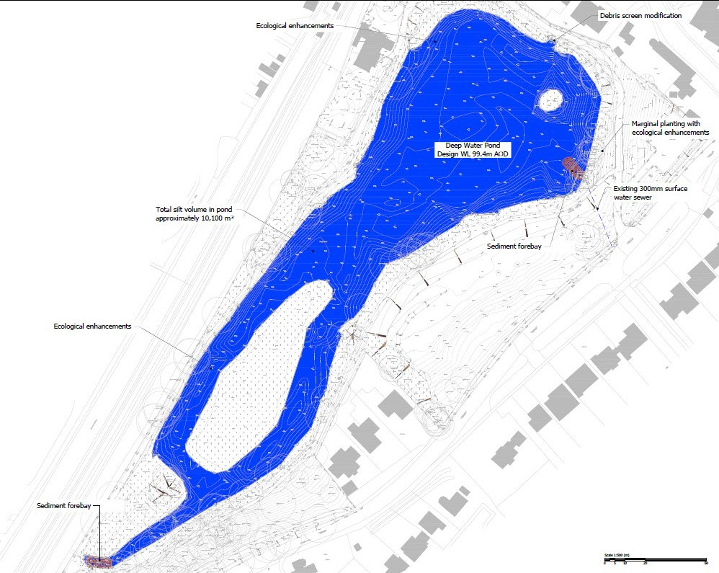

Drawing 2a Kings Pond restored after Dredging
The associated work would include improvements to the weir to reduce blockages and fluctuations in water level, reinstatement and strengthening of the banks and islands. Some silt capture could be achieved, particularly on local drainage. Ecological improvements could be included with marginal planting, reed planting and creating small wetland areas. Improvements in the woodland, grassland and paths around the pond would also be part of the project.

Although dredging would be disruptive in the short term, many residents will see the main advantage of this option being the least change to the existing wildfowl population and other characteristics of the pond. And the pond would stay a similar size. Another advantage is that it is a low risk option as we know what the finished project would look like!
The main disadvantage is that it is not a sustainable solution – silt would continue to accumulate in the pond and eventually it would need dredging again. It wouldn't remove or reduce any of the negative impacts that the pond has on the Wey. There would be no change in the range of habitats and biodiversity on the site.

The Pond & River Option: the alternative vision is of a restored river running though the site with ponds and wetland areas.
Drawing 4a shows one possible arrangement.
(Note that the yellow line is an unpaved maintenance access route on a grass bank)
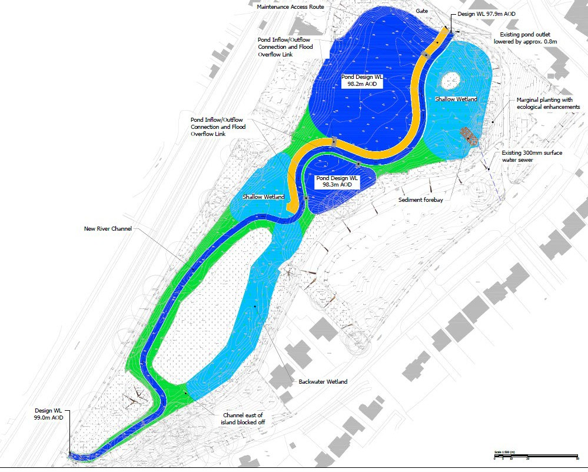

Drawing 4a – Ponds, River & Wetlands

Pond banks would be reinstated and strengthened. A variety of pond, river, marginal and wetland habitats would be created. Improvements would be made to the surrounding woodland, grassland and paths

Advantages. This is a sustainable solution for the pond – with silting minimised there would be no need for future dredging. The negative impact on the River Wey would be removed. The connectivity between the upstream and downstream reaches of the river would be restored. Forming a river channel through the site, together with recent works upstream, would restore and greatly improve the condition of this important chalk stream. A wider range of habitats would improve biodiversity.

Disadvantages: The impact on the on existing pond. One large pond would be replaced by two or more smaller ponds so there may be a reduction in waterfowl numbers as populations find their new natural levels. There is the possibility that some species will move away and give way to others as habitats and biodiversities change. This option has some risk as we cannot be completely certain of what the completed project would look like until more work has been done.

Recent Activity and Next Steps (updated at 1sy July 2025)

During November and early December 2024, ATC held public briefing sessions based on the content of this document. There were opportunities for questions and discussion. The Powerpoint presentation prepared for the Briefings was recorded and can be viewed on the ATC website.
ATC had already resolved, in January 2023, to conduct the technical and financial assessment of the Dredging Option and to carry out other investigation work.

On 8th January 2025, ATC resolved to also conduct a technical and financial assessment of the alternative Pond & River option. (Some of the work to be done is common to both options and they can be worked on in parallel.)

Ecological surveys are required for all options and some are seasonal. The necessary expenditure was approved at the Council Meeting on 6th November 2024 and the surveys are in progress. Reports are published on the ATC website as they become available.
A Task & Finish Group has been formed, comprised of councillors and local residents with relevant skills and interests. This group is responsible for moving the project forward. It is currently gathering information and identifying consultants for the design works. The next step will be to put the design work out to tender.

A Community & Stakeholder Focus Group has also been formed to share information on the King’s Pond Project and as a conduit for community feedback to the Task & Finish Group.

At each stage ATC will re-affirm that any options taken forward will be presented for comparison and consideration at public consultation before any decision to proceed with work on site.

