Name of Applicant:

This document must be completed and returned in the published format. Failure to comply with this instruction may result in your submission being rejected.

General Information

Procurement Procedure
The Town Council is inviting companies to submit responses to its Invitation to Tender for improvements to the perimeter path around its public open space known as Jubilee Playing Fields, Chawton Park Road, Alton, GU34 1RF. Access to the site can be undertaken at any time and free parking is available when a site visit is undertaken. Responses to the Invitation to Tender are requested as per the following:
- The path needs widening in places to a consistent 1.5m along its length, with PCC edging to any new and resurfaced sections as required.
- Any widening needs to be done on the outside of the path, to ensure there is no narrowing of the cricket outfield, apart from on the higher sections by the pavilions.
- The current perimeter path varies in width and there is a gap along the edge of the car park near the Skate Park, so a new section needs creating on the grass along the inside of the fence. This will then need to meet up with the existing path at the top of the slope, so a section of fence will need to be removed.
- There are two stretches which are uneven flagstones in front of each pavilion. These need replacing with a tarmac path, and all drain covers need replacing (6nr 450x 600 drain covers to remove and replace with B125 450 x 600mm ductile cover and frame).
- On the section along the south side of the site, adjacent to the railway line, tree roots have broken up sections of the path. These sections require cutting out, the tree roots need removing, and the path reinstated.
- On the north-west of the site there is a cut-through to the road where the ground has been eroded under the footpath. This requires repairing and a fence installing to divert people up the gentler slope to the side.
- At the west end of the site there is a narrow pedestrian/cycle access path that goes around the barrier gate into the car park. This requires bringing up to standard for cycle/pedestrian and mobility scooter access with a drop-kerb installed at both ends of the path (see Appendix 1).
- It is a requirement that the work will need to be undertaken in sections to ensure that access to the site is always freely available to users of the facility and including care being taken to minimise any disruption to the football pitches which will be in constant use each weekend from 21st September. Work must be completed by the end of April 2025, before the cricket season starts.
- A diagram and key is included at Appendix 1, but a site visit is required to ensure that tenderers take their own accurate measurements for the work being tendered for. A site meeting can be arranged with the Head Groundsman should this be required with all appointments to be booked via the Town Hall.
- An area for a contractor compound will be agreed with the successful tenderer.
- All surplus materials are to be removed from site.

Procurement Timetable
The Authority proposes the following timetable for the award of the Contract:
Procurement Stage | Dates
Publication of advertisement | 12th August 2024
Clarification questions to be submitted by | 30th August 2024
Clarification responses to be issued by | 10th September 2024
Bid Deadline | 17th September 2024
Evaluation | 19th September 2024
Intention to award | 9th October 2024
Contract start | To be agreed
The Council reserves the right to change the above timetable and Applicants will be notified accordingly if there is a change.

Council Representatives
Authorised Representative contact details: | Procurement Representative contact details:
Pat Harris -Town Clerk  Town Hall, Market Square, Alton, Hampshire  GU34 1HD  townclerk@alton.gov.uk  01420 83986 | Hayley Carter, Deputy Clerk  Town Hall, Market Square, Alton, Hampshire  GU34 1HD  admin@alton.gov.uk  01420 83986 / 07909 251105

Contract Period
The path works must be completed by the end of April 2025

Insurance Levels

Employer’s Liability Insurance
The Council’s minimum requirement for Employer’s Liability Insurance is £10 million

Professional Indemnity Insurance
The Council’s minimum requirement for Professional Indemnity Insurance is £2 million.

Public Liability Insurance
The Council’s minimum requirement for Public Liability Insurance is £10 million

Selection Questionnaire

2.Background Information

The Town Council are looking to upgrade the existing path to provide a safe space for people of all ages and abilities to exercise in a variety of ways without having to pay to do so.

This project will provide a continuous path, almost exactly 1km long, around the edge of the playing fields, so people can safely walk or run or ride their bikes, and of course it will also be suitable for wheelchair users.

The space is already used by many people of all ages and abilities, but at present, in order to do a full circuit, they have to either venture onto the pitches, which they cannot do when there are matches on, or through the car park, which is not very safe.

Added Value
The Applicant will be expected to suggest any added value that their offer might be able to bring to the Council. Applicants are expected to build any such offers into their submissions regardless of whether specific questions are asked along these lines or not.
Applicants’ attention is drawn to the fact that the Council has declared a climate emergency and is therefore keen to ensure the supply chain reduces carbon emissions wherever possible and where such savings can be made, they are evidenced. e.g locally sourced construction materials, recycling of waste matter generated etc..

Selection Questionnaire

Notes for completion
1. “Council” means the public sector contracting body, that is seeking to invite suitable suppliers to participate in this procurement process.
2. “You”/ “Your” or “Supplier” means the body completing these questions i.e. the legal entity seeking to be invited to the next stage of the process and responsible for the information provided. The ‘Supplier’ is intended to cover any economic operator as defined by the Public Contract Regulations 2015 and could be a registered company; charitable organisation; Voluntary Community and Social Enterprise (VCSE); Special Purpose Vehicle; or other form of entity.
3. This Selection Questionnaire has been designed to assess the suitability of a Supplier to deliver the Authority’s contract requirement(s). If you are successful at this stage of the procurement process, you will be selected for the subsequent award stage of the process.
4. Please ensure that all questions are completed in full, and in the format requested. Failure to do so may result in your submission being disqualified. If the question does not apply to you, please state clearly ‘N/A’.
5. Should you need to provide additional Appendices in response to the questions, these should be numbered clearly and listed as part of your declaration. A template for providing additional information is provided at the end of this document.
6. Please return a completed version of this document in accordance with the Submission requirements.
Verification of Information Provided
7. Whilst reserving the right to request information at any time throughout the procurement process, the Council may enable the Supplier to self-certify that there are no mandatory/ discretionary grounds for excluding their organisation. When requesting evidence that the supplier can meet the specified requirements (such as the questions in section 7 of this Selection Questionnaire relating to Technical and Professional Ability) the Council may only obtain such evidence after the final tender evaluation decision i.e. from the winning Supplier only.
Sub-contracting arrangements
8.The contractor shall not without the Council’s written consent sub-contract the whole or any parts of the works. Such consent shall not be unreasonably delayed or withheld but the contractor shall remain wholly responsible for carrying out and completing the works in all respects. Any sub-contractor’s employment under a sub-contract shall terminate immediately upon the termination for any reason of the contractor’s employment under this contract. The Council will never be liable for any payment which should properly have been paid from the contractor to the sub-contractor
Variations
9. Any inconsistency in or between the contract documents, locations plans and schedules of work shall be corrected and any such correction which results in addition, omission or other change shall be treated as a variation.
The Town Council may, without invalidating this contract, issue instructions requiring addition to, or omission from, or other change in the schedule of works or the order or period in which the works are to be carried out. The Council and the contractor shall endeavour to agree a price prior to the contractor carrying out the instruction. Failing any agreement to do so, any instruction issued shall be valued by the Town Council on a fair and reasonable basis using any relevant prices in the priced schedule of works and the valuation shall include any direct loss and/or expense incurred by the contractor due to the regular progress of the works being affected by compliance with the instruction.
If following receipt of an instruction from the Council, the contractor does not comply, the Council may employ and pay another person to execute any work whatsoever which may be necessary to give effect to that instruction. The contractor shall be liable for all additional costs incurred by the Council in connection with such employment and an appropriate deduction shall be made from the contract sum.
Confidentiality
10. When providing details of contracts in answering section 6 of this Selection Questionnaire (Technical and Professional Ability), the Supplier agrees to waive any contractual or other confidentiality rights and obligations associated with these contracts.
11. The Council reserves the right to contact the named customer contact in section 6 regarding the contracts included in section 6. The named customer contact does not owe the Council any duty of care or have any legal liability, except for any deceitful or maliciously false statements of fact.
12. The Council confirms that it will keep confidential and will not disclose to any third parties any information obtained from a named customer contact, other than to the Cabinet Office and/or contracting authorities defined by the Public Contract Regulations.

- Supplier Information
1.1 Supplier Details |  | Answer
Full name of the Supplier completing the Selection Questionnaire
Registered company address
Registered company number
Date of Incorporation
Registered VAT number
Name of parent company (if applicable)
Please mark ‘X’ in the relevant box to indicate your trading status |  | - a public limited company
 |  | - a limited company
 |  | - a limited liability partnership
 |  | - other partnership
 |  | - sole trader
 |  | - other (please specify)
1.2 Contact Details
Supplier contact details for enquiries about this Selection Questionnaire
Name
Postal address
Country
Phone
Mobile
E-mail
- Professional Ability
Relevant experience and contract examples
Please provide details of any contracts awarded for your business and trading history. Please note we reserve the right to contact anyone listed to discuss their experience using your company.

Declaration
I declare that to the best of my knowledge the answers submitted to these questions are correct. I understand that the information will be used in the selection process to assess my organisation’s suitability to be invited to participate further in this procurement, and I am signing on behalf
Of (Insert name of supplier).
I understand that the Council may reject my submission if there is a failure to answer all relevant questions fully or if I provide false/misleading information. I have provided a full list of any Appendices used to provide additional information in response to questions.
I also declare that there is no conflict of interest in relation to the Authority’s requirement.

SELECTION QUESTIONNAIRE COMPLETED BY
Name
Role in organisation
Date

Award

Award Criteria
The following criteria and weightings will be applied in the evaluation of the questions asked of Applicants within this section 4 Award.
Evaluation Criteria Breakdown | Means of Evaluation
Price | 65%
Experience working with local authorities | 15%
Demonstration of sustainable practices ( eg supply chain, recycling, re-use of spoil materials) | 20%

Scoring Guidelines
The questions asked of Applicants within this section 4 Award shall be scored using the marking system described within this section. Applicants should refer to the Council’s minimum requirements to ensure that they meet or exceed the minimum requirements wherever possible.
Applicants should be aware that the responses provided to the questions will be evaluated in such a way that the highest scores will be awarded to Applicants who show innovation, creativity, further relevant details and information that could potentially enhance the Applicant’s proposal. It should be noted that to achieve the highest scores available the Applicant must not only meet but exceed the Council’s minimum requirements, where these are stated.
All scored question shall be evaluated in accordance with the guidelines below:
Score 0 | No response | No response
Score 1 | Extremely Weak | Very poor proposal/response; does not cover the associated requirements, major deficiencies in thinking or detail, significant detail missing, unrealistic or impossible to implement and manage | Weak
Score 2 | Very Weak | Poor proposal/response, only partially covers the requirements, deficiencies in thinking or detail apparent, difficult to implement and manage | Weak
Score 3 | Weak | Mediocre proposal/response, moderate coverage of the requirements, minor deficiencies either in thinking or detail, problematic to implement and manage | Weak
Score 4 | Fair - Below Average | Proposal/response partially satisfies the requirements, with small deficiencies apparent, needs some work to fully understand it | Fair - Good
Score 5 | Fair - Average | Satisfactory proposal/response, would work to deliver all of the Council's requirements to the minimum level | Fair - Good
Score 6 | Fair - Above Average | Satisfactory proposal/response, would work to deliver the majority of the Council's requirements to the minimum level with some evidence of where the Applicant could exceed the minimum requirements | Fair - Good
Score 7 | Good | Good proposal/response that convinces the Council of its suitability, response slightly exceeds the minimum requirements with a reasonable level of detail | Fair - Good
Score 8 | Strong | Robust proposal/response, exceeds minimum requirements, including a level of detail or evidence of original thinking which adds value to the bid and provides a great deal of detail | Strong - Excellent
Score 9 | Very Strong | Proposal/response well in excess of expectations, with a comprehensive level of detail given including a full description of techniques and measurements employed | Strong - Excellent
Score 10 | Outstanding/ Excellent | Fully thought through proposal/response, which is innovative and provides the reader with confidence of the suitability of the approach to be adopted due to the complete level of detail provided | Strong - Excellent

Project Costs

Project Costings
Applicants are required to give their bid price on the table below and provide all supporting documentation required to substantiate or in support of your price
Item Number | Description |  | Price (£)
1
2
3
 | Total of the prices (excluding VAT)

Certificates

Conditions of Tender
ALTON TOWN COUNCIL
CONDITIONS OF TENDER
Reference number and Title of Contract: Shall be as per the Reference Number and Title of Contract as detailed on page one (1) of this Volume Two (2) Applicant’s Offer

1. | Tenders are invited for the supply of the goods or services specified or described in the invitation. Tenders with conditions of contract duly completed should be marked with the title of the Contract and returned electronically to: townclerk@alton.gov.uk. Tenders must be returned no later than the specified time and date. Tenders received after the time stated or not properly completed will be disregarded. Facsimile copies will not be accepted.
2. | The Contract shall be subject to the specified terms and Conditions of Contract. Offers by Applicants made subject to additional or alternative conditions may not be considered and may be rejected on the grounds of such conditions alone. No alteration must be made to the printed conditions or schedules. Any Tenders bearing such alterations will not be considered.
3. | The Council does not bind itself to accept the lowest or any Tender, and reserves the right to accept a Tender either in whole or in part, for such item or items specified in the Invitation to Tender, and for such place or places of delivery as it thinks fit, each item and establishment being for this purpose considered as Tendered for separately.
4. | To ALTON TOWN COUNCIL  I/We the undersigned DO HEREBY UNDERTAKE on the acceptance by the Council of my/our Tender either in whole or in part, to supply (or perform the services), on such terms and conditions and in accordance with such specifications (if any), as are contained or incorporated in the Invitation to Tender. I/We agree and declare that the acceptance of this Tender by letter on behalf of the Council, whether for the whole or part of the items included therein, will constitute a Contract for the supply of such items, I/We agree to enter into a further agreement for the due performance of the Contract, and I/We declare that I am/We are acting as the Delegated Authority for the purposes of signing off this Tender, and therefore, the Contract.
Signed: |  | Date:
Name (in block capitals):

In the capacity of: (State official position, i.e. Director, Manager, etc.)

Certificate of Confidentiality
CERTIFICATE OF CONFIDENTIALITY
I/we hereby agree with the Authority that I/we shall not at any time divulge or allow to be divulged to any person any information, confidential or otherwise, relating to information passed to me regarding this project.
It is appreciated by the parties that in the event of negotiations in respect of the proposed Contract being entered into between the Authority and my organisation that it may be necessary to share information with colleagues within my organisation. In this event this confidentiality clause may be waived to allow such information sharing to take place but not further or otherwise.
Signed*: | Date:
Name (in block capitals):
In the capacity of: (State official position, i.e. Director, Manager, etc.)
*(It must be clearly shown whether the Applicant is a limited company, statutory corporation, partnership or single individual, trading under his own or another name, and also if the signatory is not the actual Applicant, the capacity in which he/she signs or is employed).

Commercially Sensitive Information
I declare that I wish the following information to be designated as Commercially Sensitive.
The reason(s) it is considered that this information should be exempt under Freedom of Information Act 2000 is:

Conflict of Interest
CERTIFICATE OF CONFLICT OF INTEREST
I/we hereby notify the Authority that I/we consider the following declaration to be a conflict of interest (Applicant to insert details of the conflict of interest):

I/we hereby understand that in accordance with Article 24 of the Public Contract Regulations 2015 that the Authority is obliged to take appropriate measures to effectively prevent, identify and remedy conflicts of interest arising in the conduct of procurement procedures so as to avoid any distortion of competition and to ensure equal treatment of all economic operators.
Signed*: | Date:
Name (in block capitals):

In the capacity of: (State official position, i.e. Director, Manager, etc.)
*(It must be clearly shown whether the Applicant is a limited company, statutory corporation, partnership or single individual, trading under his own or another name, and also if the signatory is not the actual Applicant, the capacity in which he/she signs or is employed).

Appendix 1 – Diagram and measurements

Perimeter Path:

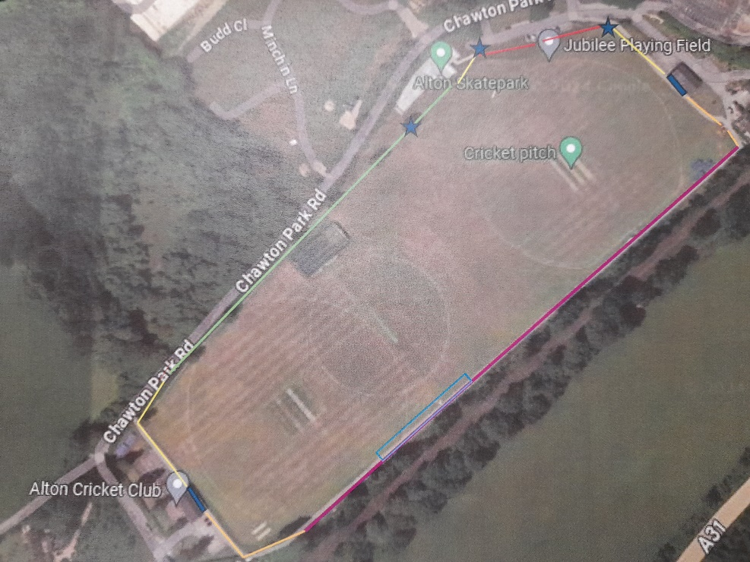
Key to Plan
Widen path by 500mm and carry out overlay
Widen path by 300mm and carry out overlay
No Works required to this section of path (290Lm)
Overlay only with new AC6 tarmac to 30mm depth (344Lm)
New tarmac path 1.5m wide x 89Lm
Patch repairs or removal of existing tarmac to remove humps/ fencing
Remove root damaged tarmac sections and relay

Small path around gate at west end of fields which needs widening and drop kerb installing:
